# Lab 2: Agile Backlog Creation & Sprint Simulation in Jira

## Objective:

Use Jira to turn functional requirements into Agile backlog items, simulate a sprint, and analyse progress.

## Duration:

**90 minutes**

## Software Requirement:

In **Lab 1**, you identified **functional requirements** for a Coffee Ordering Kiosk System. These requirements will now be **converted into Epics and User Stories**, prioritized, estimated, and used to run a **mini-sprint** using **Jira**.

**What You Need**

* Jira account (sign up if you haven’t already).
* Lab 1 functional requirements (review and reuse them).

## Learning Outcomes

By the end of this lab, students will be able to:

* **Define and create Epics and User Stories** in Jira using Agile conventions, ensuring clarity in functional requirements and end-user goals.
* **Prioritize backlog items** based on business value and user needs, and organize them in a structured Agile backlog.
* **Assign Story Points** to User Stories using the Fibonacci sequence to estimate effort, complexity, and uncertainty.
* **Apply Planning Poker** as a collaborative estimation technique to foster team alignment on task difficulty.
* **Simulate a Sprint** by creating Sprint 1 in Jira, populating it with selected backlog items, and progressing tasks across To Do → In Progress → Done.
* **Monitor Sprint progress** using Jira’s **Burndown Chart** to track work completion against planned velocity.
* **Reflect on team performance** and Agile workflow through group discussion and analysis of Sprint outcomes.

## Deliverables:

* Screenshot of:
  + Jira backlog with Epics and User Stories.
  + Story point assignments.
  + Sprint board (Active Sprint view).
  + Burndown Chart.
* A brief document answering the reflection questions.

### **Note**: Upon completion of all lab activities, students are required to demonstrate their Jira workspace to the instructor for evaluation. Please ensure your backlog, sprint boards, story point assignments, and burndown charts are ready for review to receive full marks for this laboratory session.

## Example:

|  |  |  |  |
| --- | --- | --- | --- |
| **Epic 1: Customer Ordering Experience** | | | |
| **Description: Enable customers to browse, customize, and place coffee orders through an intuitive self-service interface.** | | | |
| **User Stories:** | **As a** | **I want to** | **So that** |
| **Story 1.1: Coffee Selection** | **As a customer** | **I want to browse and select from different coffee types (Espresso, Americano, Latte, Cappuccino)** | **So that I can choose my preferred beverage** |
| **Story 1.2: Size Selection** | **As a customer** | **I want to choose my drink size (Small, Medium, Large)** | **So that I can get the right portion for my needs** |

## Steps:

1. **Set Up Your Jira Project**
2. **Log into your Jira account or open Jira account in your browser.** 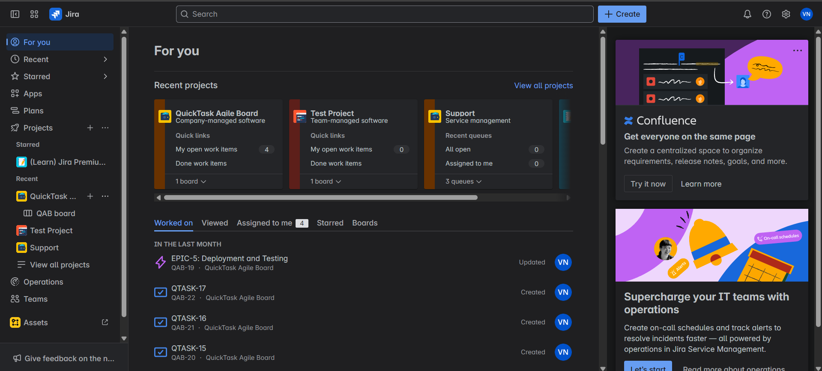
3. **Click on the “+” logo next to Projects.** 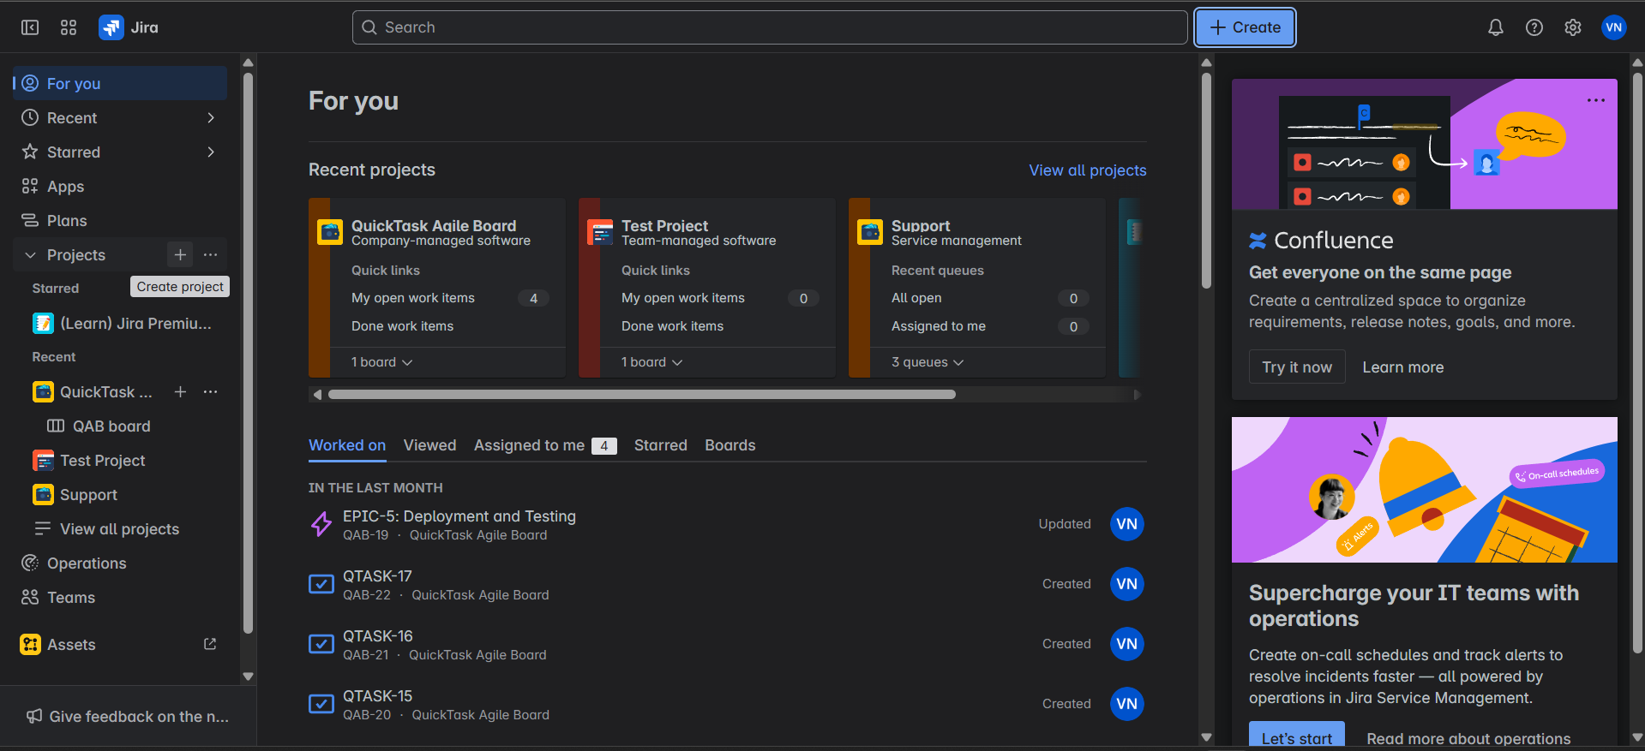
4. **Select Software Development and Choose SCRUM and use template.** 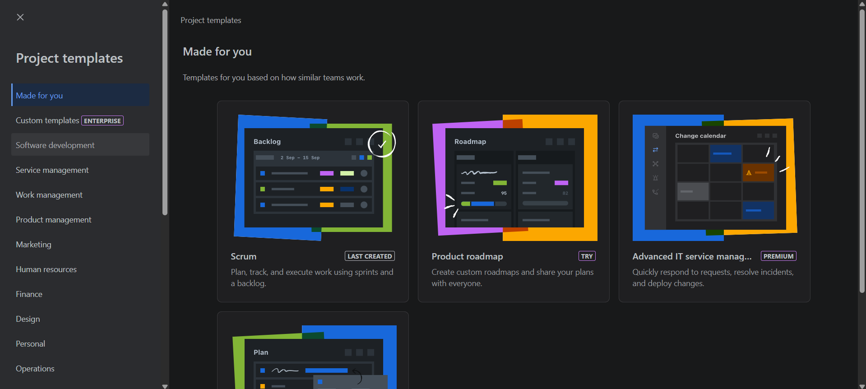

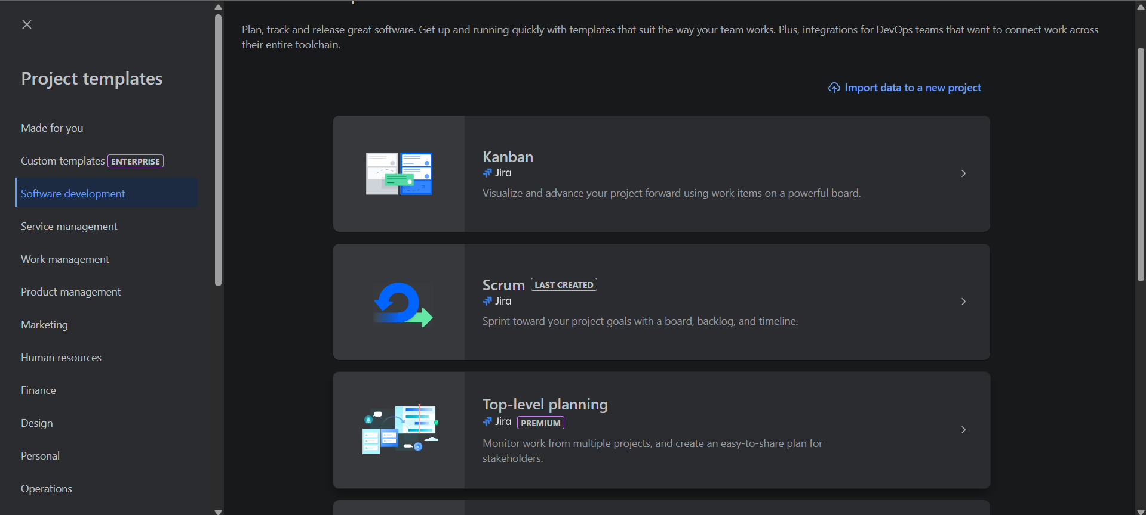



1. **Choose Company-managed Project Type.** 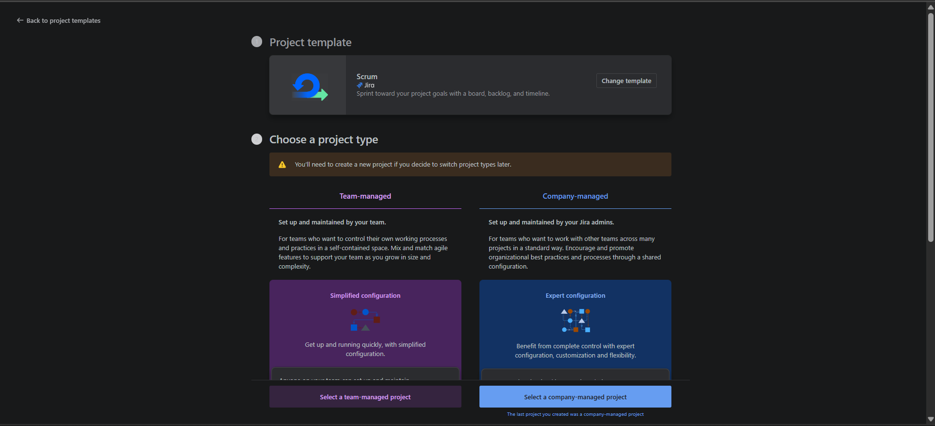
2. **Name your Project and click next.** 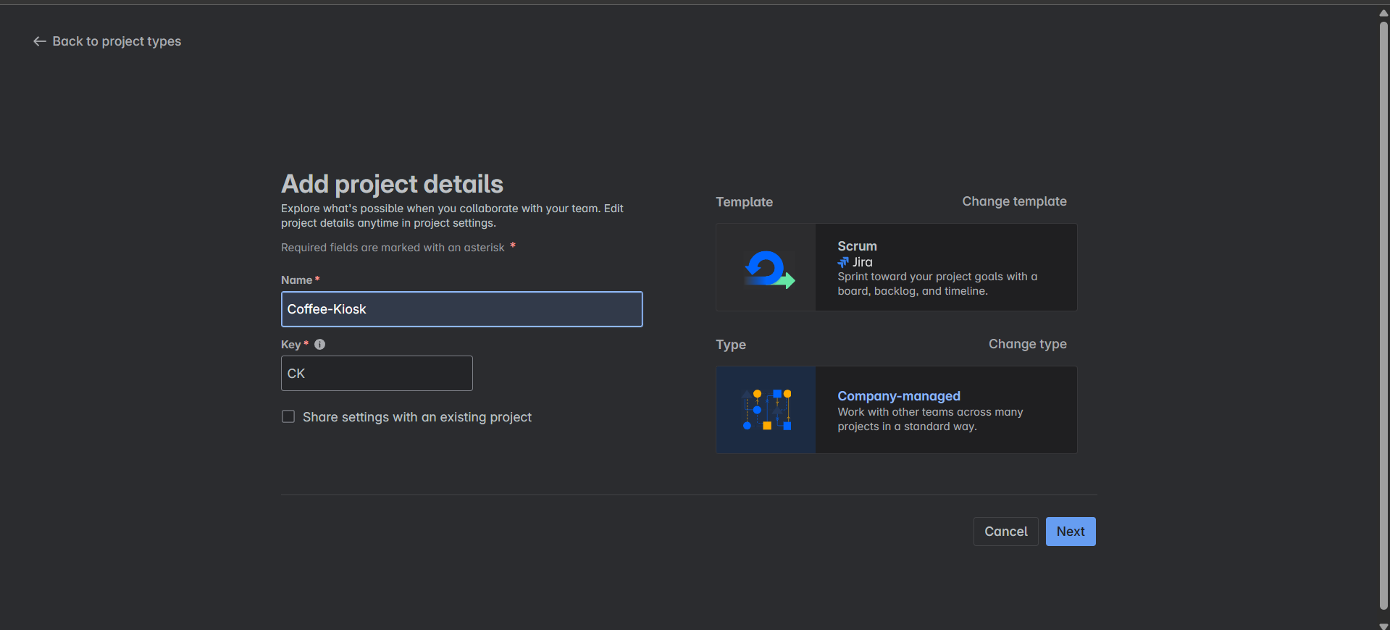
3. **Now you’ll see your SCRUM Board created in Jira.** 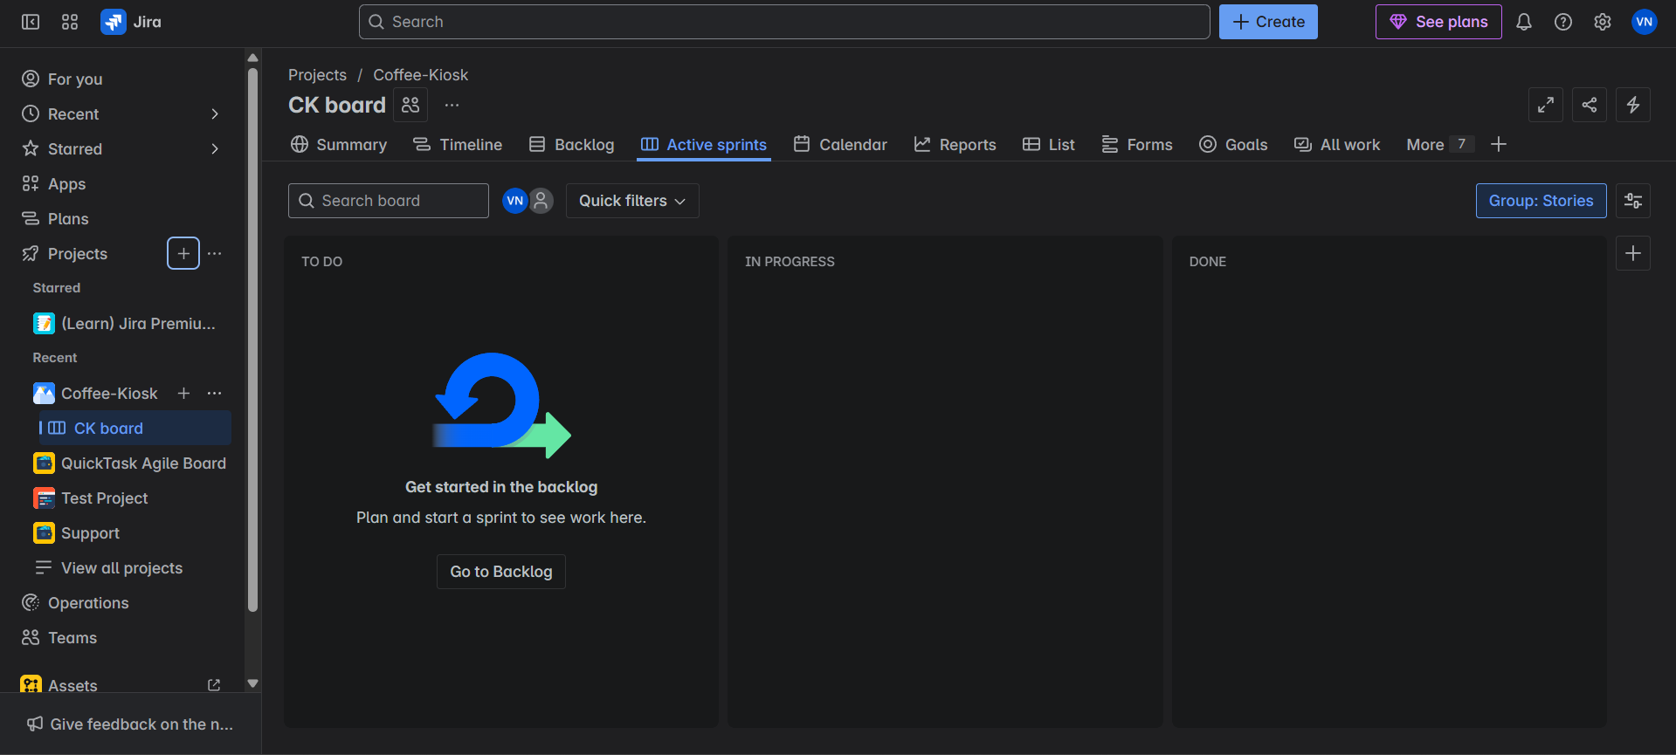
4. **Create Epics**

***Epic:***

**An agile epic is a body of work that can be broken down into specific tasks (called user stories) based on the needs/requests of customers or end-users. Epics are an important practice for**[**agile**](https://www.atlassian.com/agile/teams)**and**[**DevOps**](https://www.atlassian.com/devops/what-is-devops)**teams.**

**Epic allows us to break down large complex tasks into small easier ones.**

* Break down your **Lab 1 requirements** into major functional themes (Epics).
* Example Epic: *Customer Ordering Experience*
  + Description: Enables customers to select, customize, and order coffee.

1. **Go to Backlogs, this is where you create Sprints, Epics, User Stories, Tasks and Subtasks.** 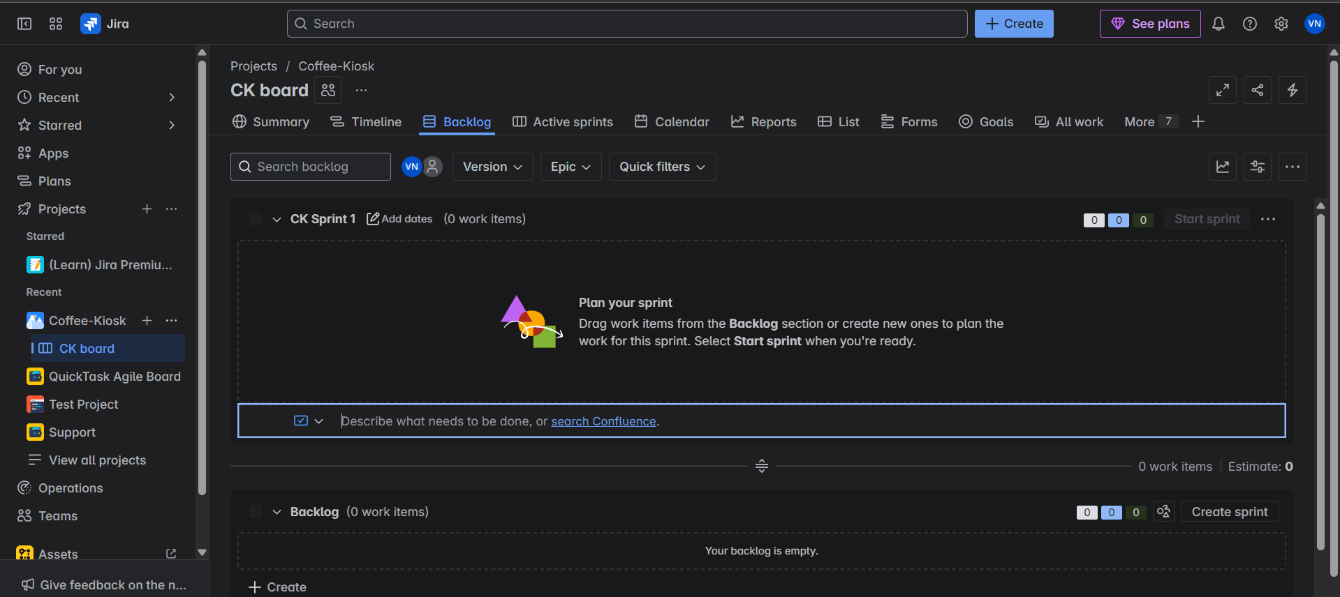
2. **Click on the blue Create button near the search bar, and choose Epic from the work type drop down, scroll down and in Summary name you Epic or you can say EPIC1 and add description (refer to the above example) for the Epic and click create to create your Epic.** 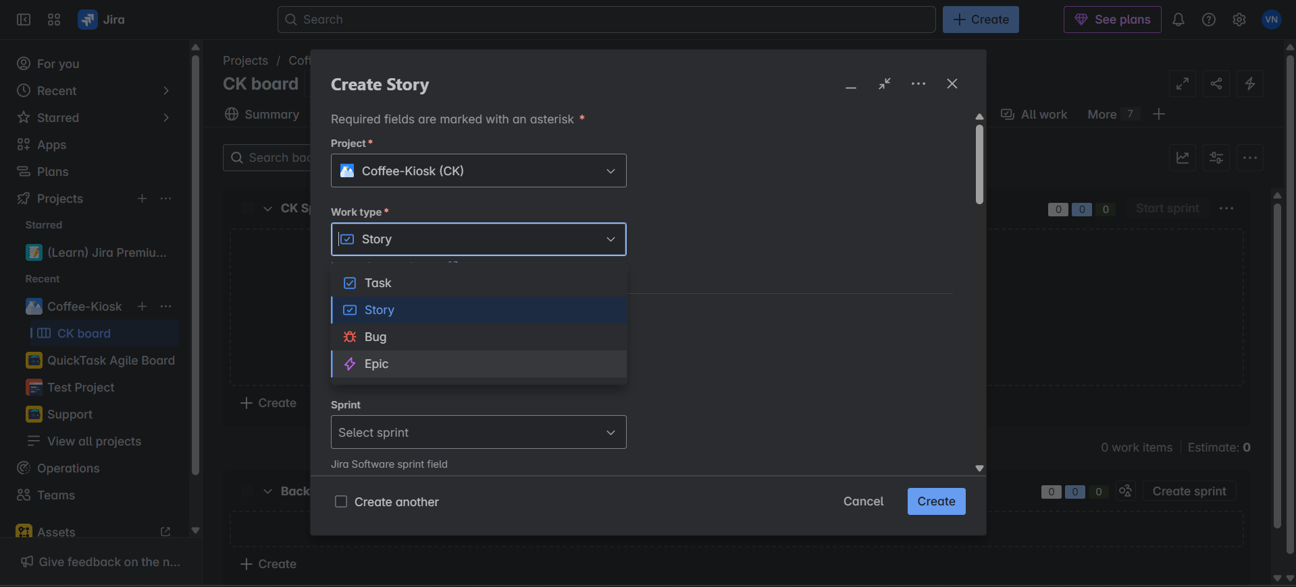

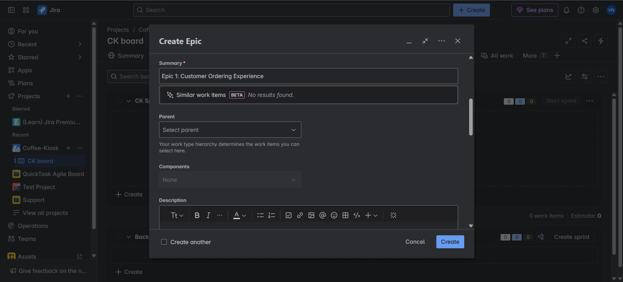

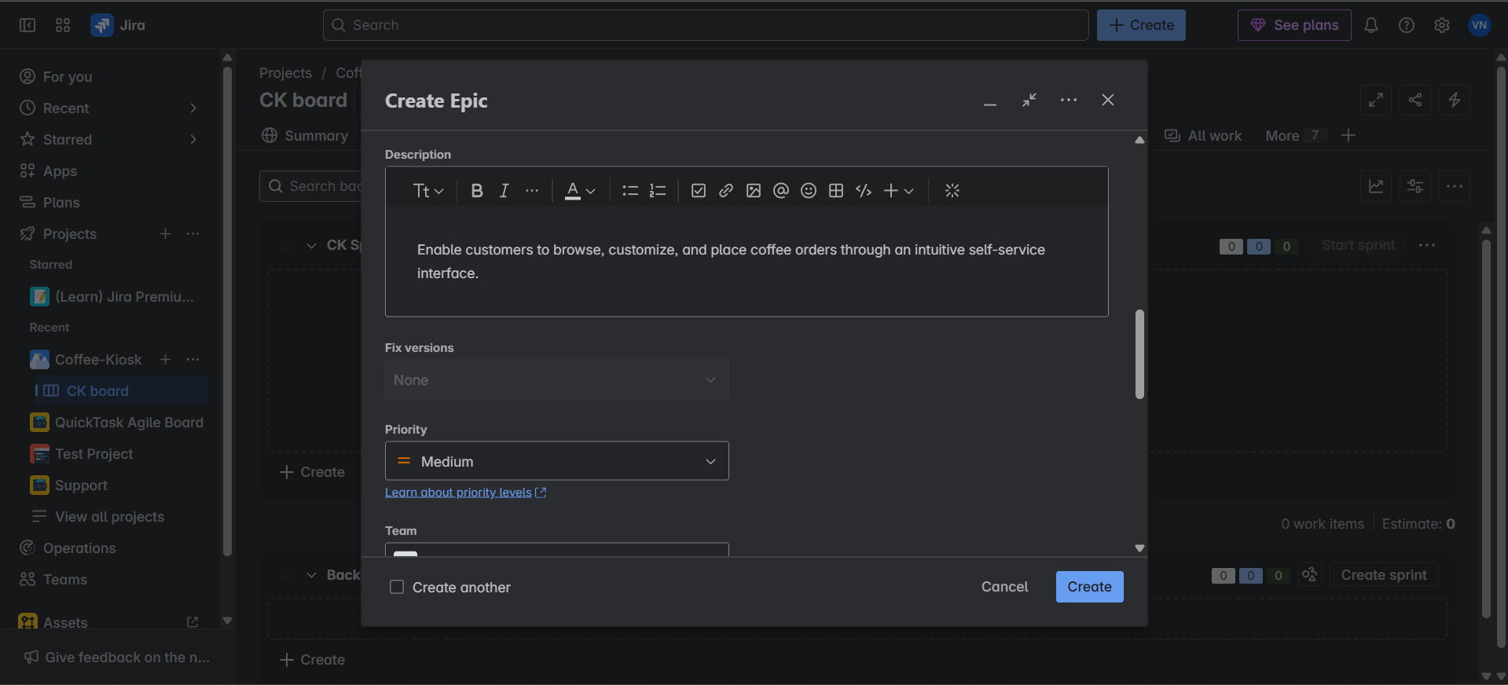

1. **Press “E” key on your keyboard or you can click on Epic that you see in the backlog panel board and enable show epic panel.** 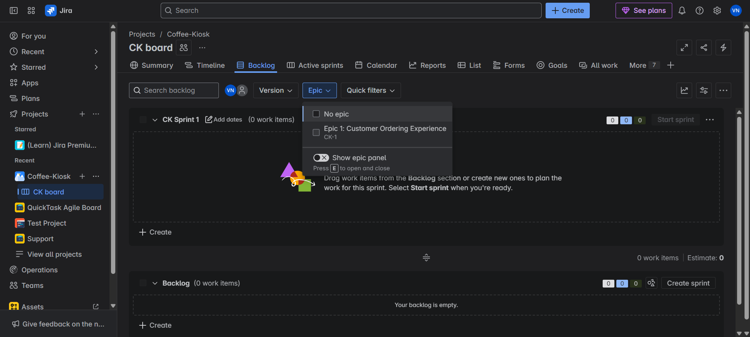

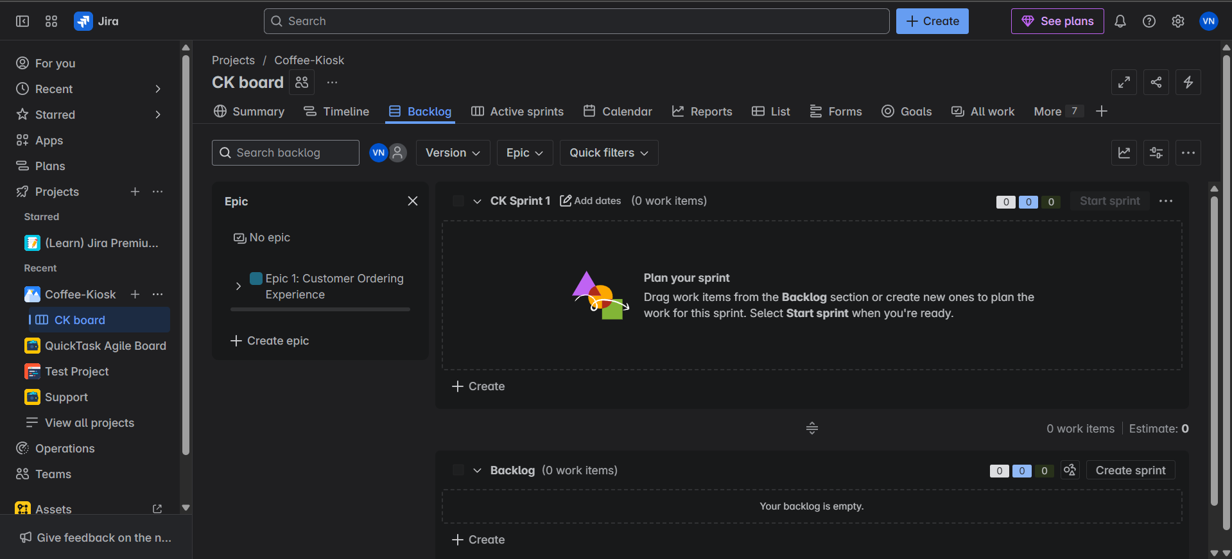

**Create the necessary Epics before making User Stories for them. Once you’ve identified and made the necessary Epics with the Functional Requirements, create User Stories.**

1. **Write User Stories**

***User Stories*:**

**A user story is an informal, general explanation of a software feature written from the perspective of the end user. Its purpose is to articulate how a software feature will provide value to the customer. It's tempting to think that user stories are, simply put, software system requirements. But they're not.**

**User story gives us the perspective of the end-user or Customer.**

* For each Epic, write related User Stories using the format:

As a [user role],

I want [goal],

So that [benefit].

* User Stories follow the above format. (e.g.: - As a: frequent app user, I want: to receive push notifications for important updates, so that: I can stay informed while on the go.
* **Example:** 
  1. **Story 1.1: Coffee Selection:**

**As a customer,**

**I want to browse and select from different coffee types (Espresso, Americano, Latte, Cappuccino),**

**So that I can choose my preferred beverage**

* 1. **Story 1.2: Size Selection:**

**As a customer**

**I want to choose my drink size (Small, Medium, Large)**

**So that I can get the right portion for my needs**

* + 1. **Click on the arrow next to the Epic/Epic Name and you’ll see “View Details” and “Create work item”.** 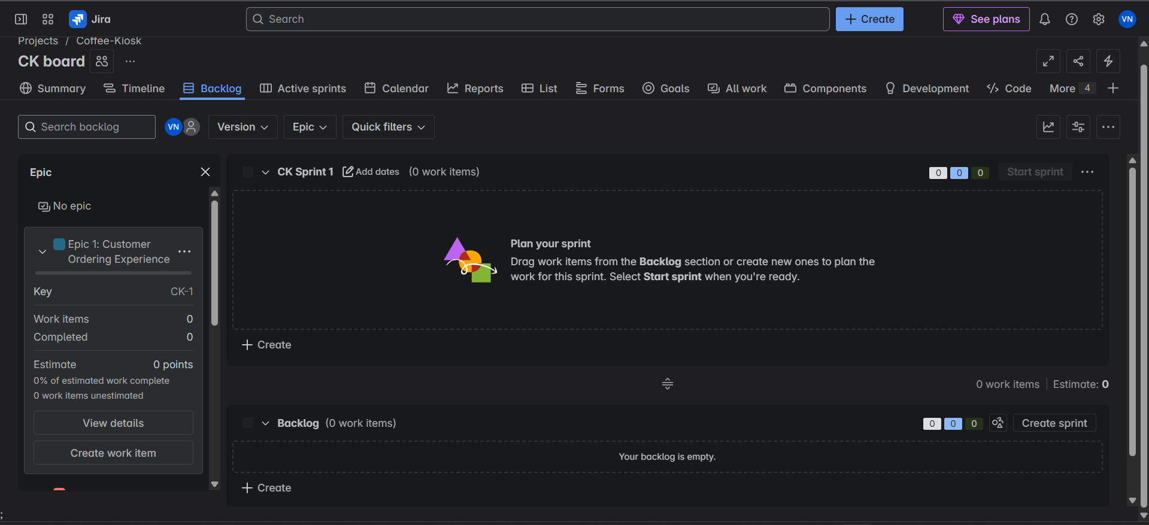

**This is due to the new Jira development where the Work Items are User Stories, Tasks and Subtasks.**

**Click on “Create work item”, by default, it shows story, if not click on the drop down and choose work type as Story.** 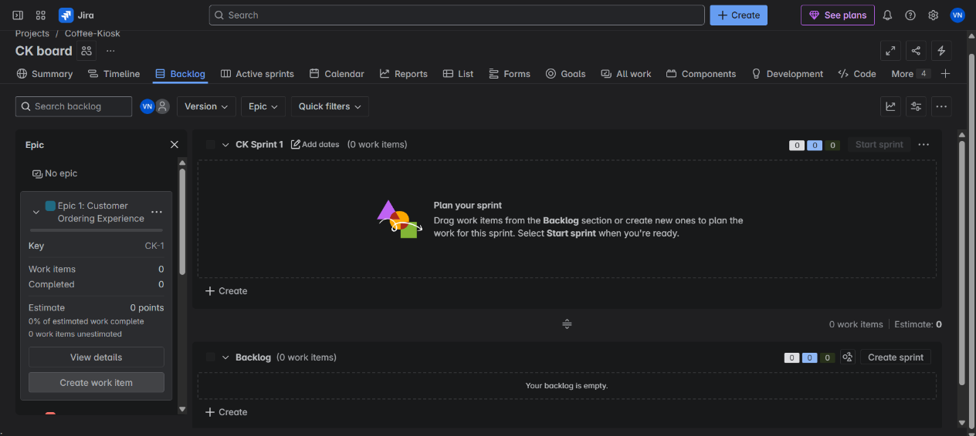

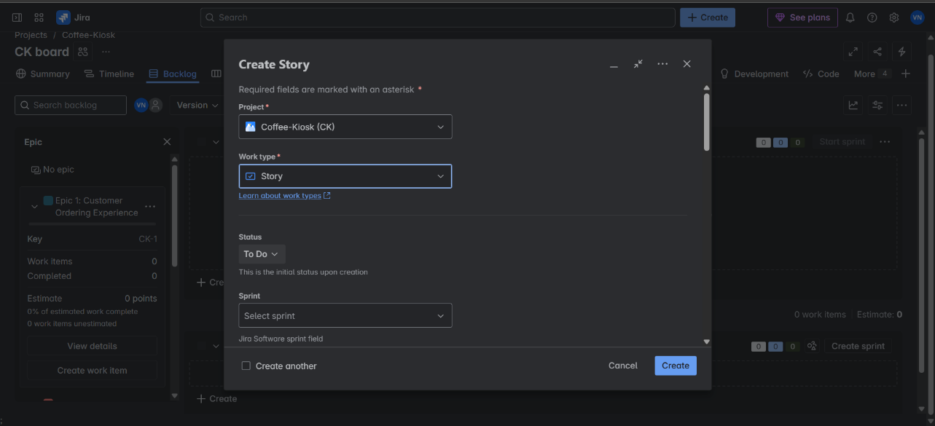

* + 1. **Similar to Epic, add the User Story Title as summary and describe the User Story.** 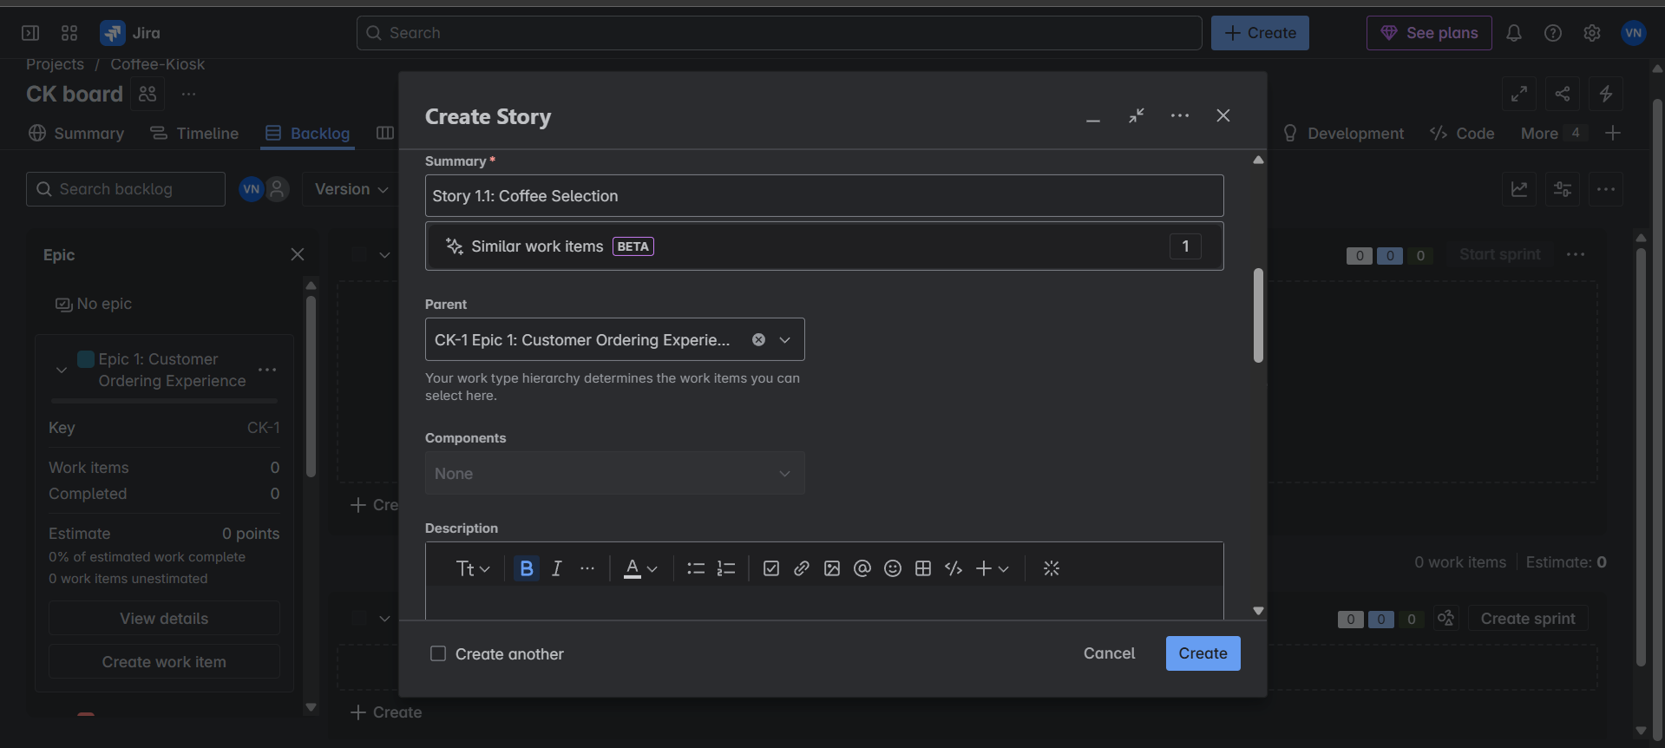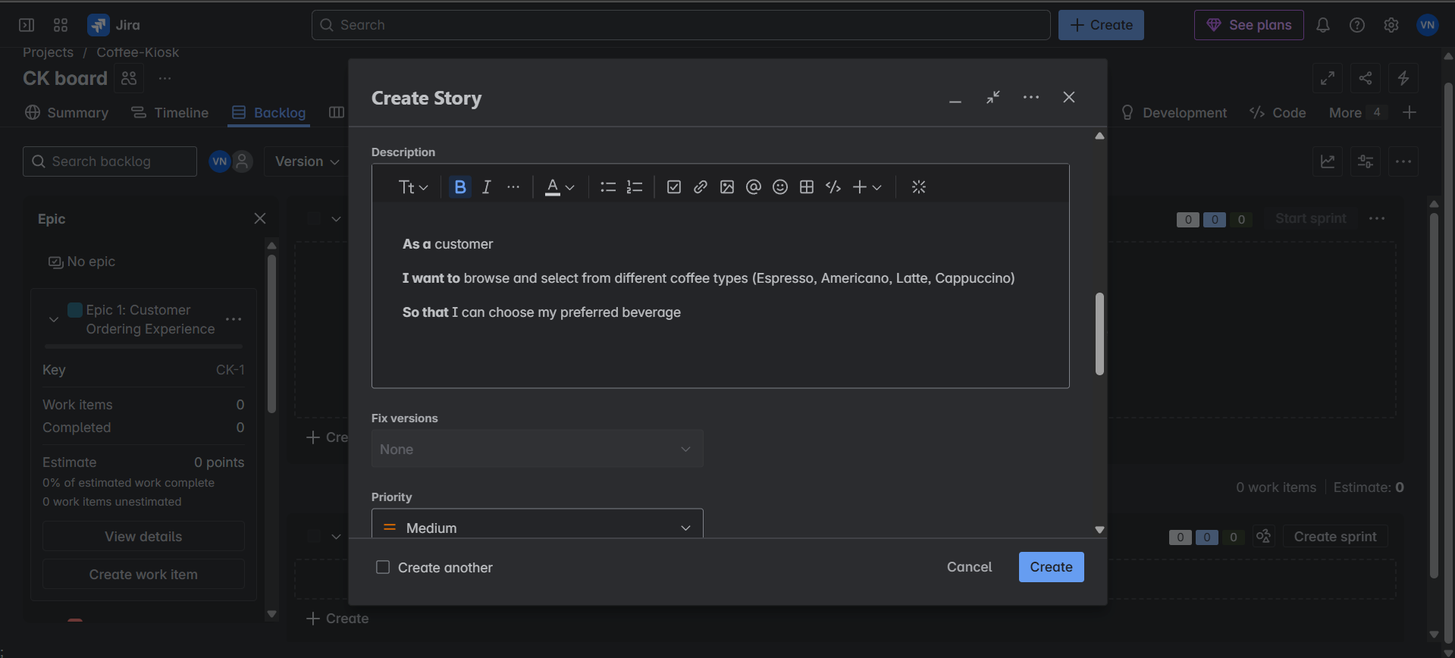
    2. **Now you’ll see from the initial empty Backlog panel will now be populated and the change in Epic can be noticed. It shows a work item added to the Epic.** 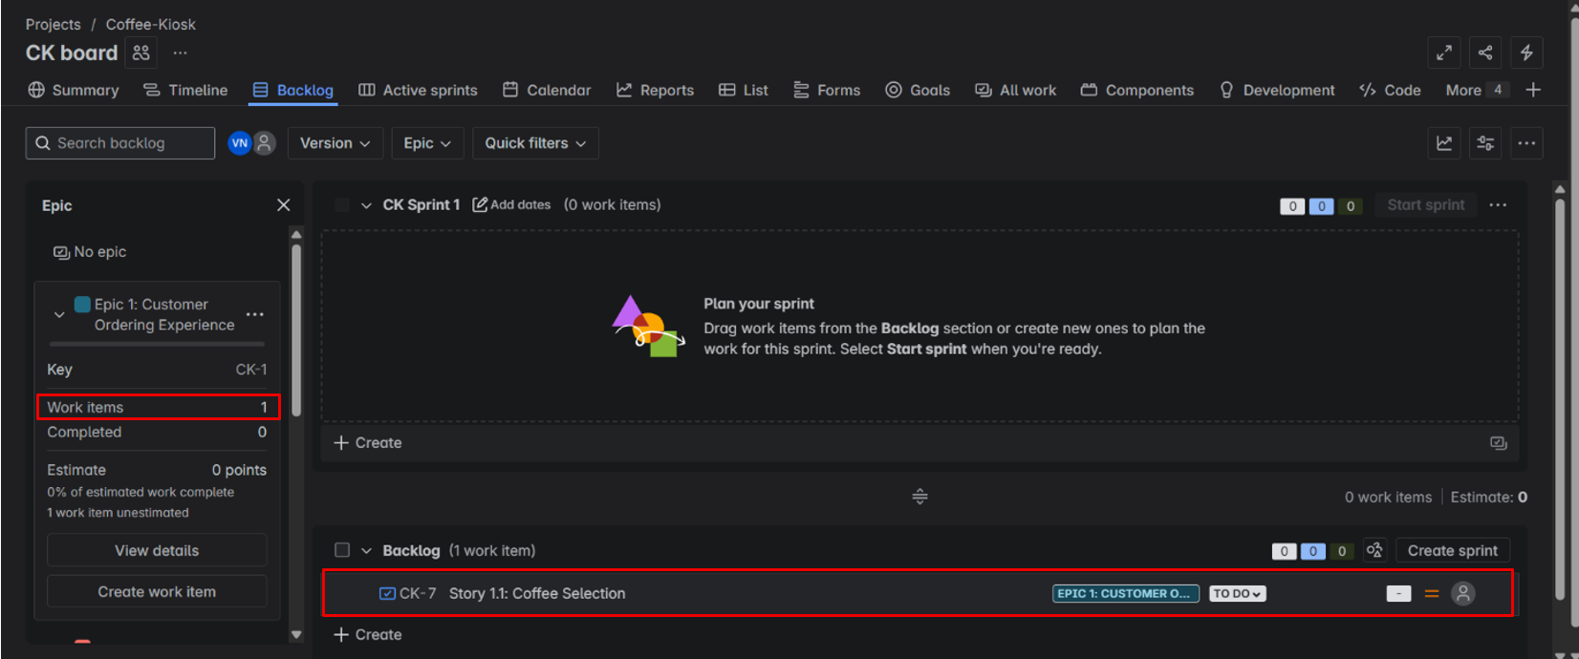
    3. **Create all the user stories respective to their Epics and populate the backlog. Click on any Epic and the User Stories to those Epics are shown in the backlog, making it easier to view common User Stories under an Epic.** 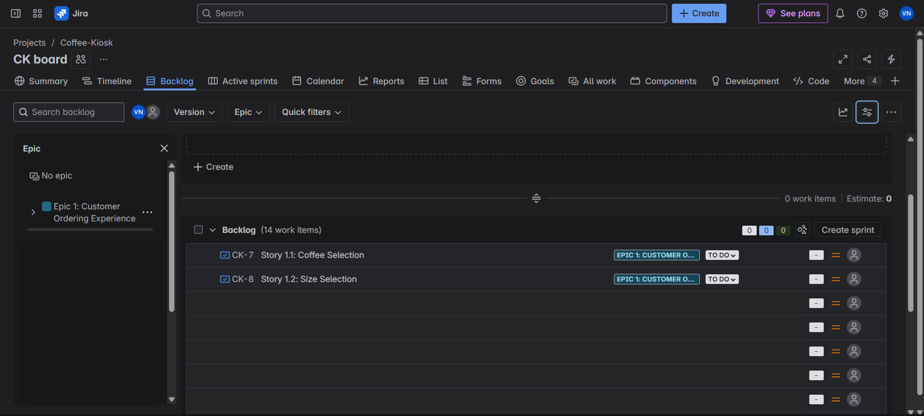

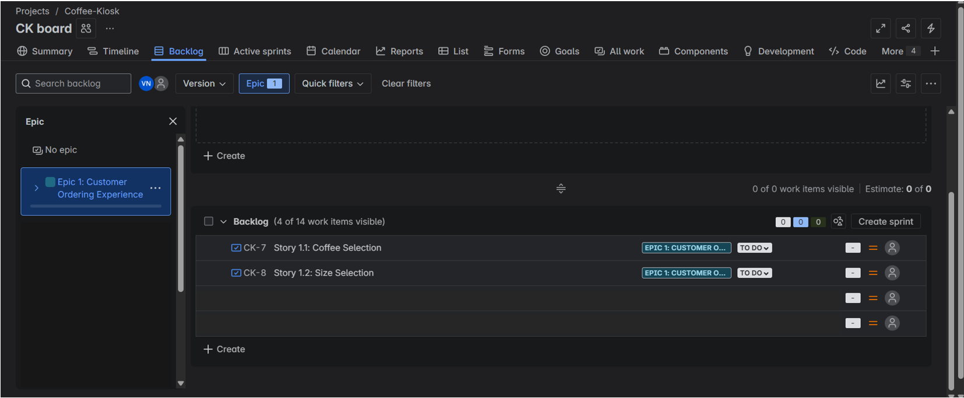

1. **Prioritize the Backlog**

* Reorder your User Stories in Jira by priority.
* Assign each a priority level (High, Medium, Low) based on user impact.
  1. **You can change the Priority status of tasks, by default to each User Story is set to Medium Priority. You can even set your User Story priority task while creating the User Story as well.**

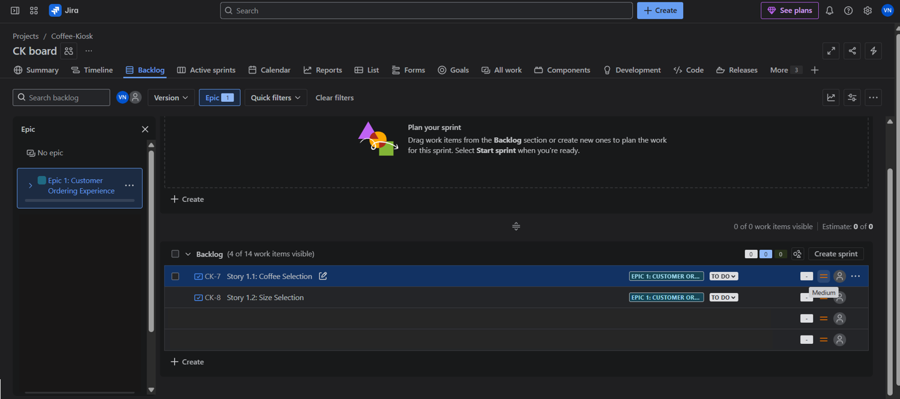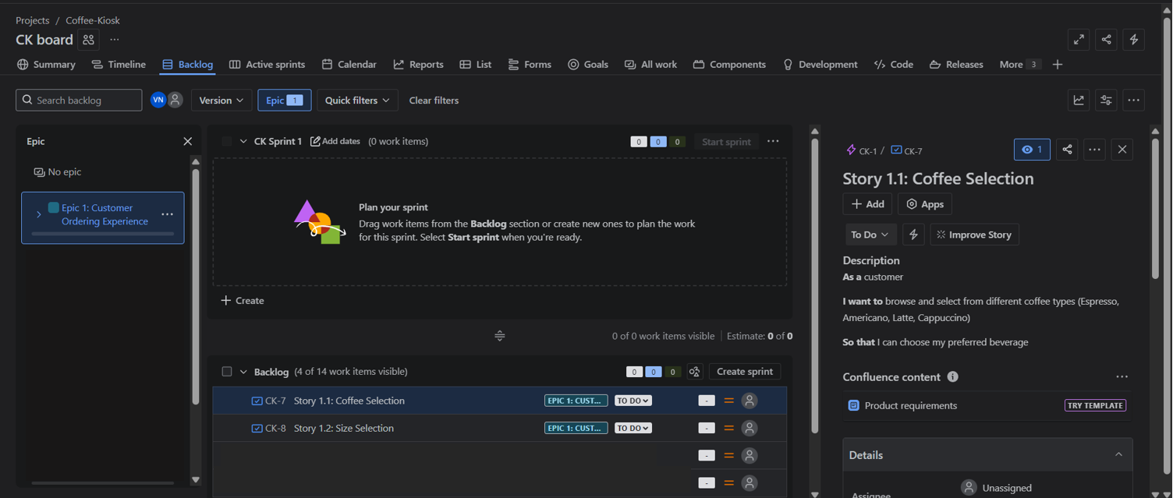

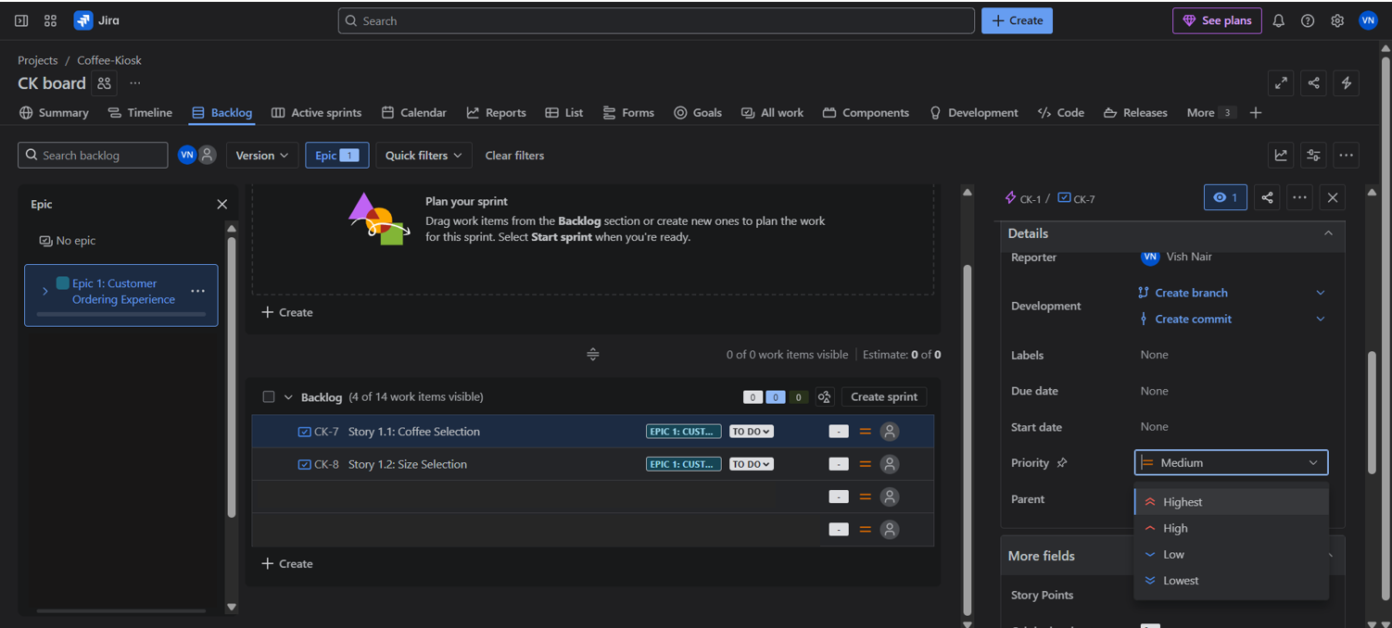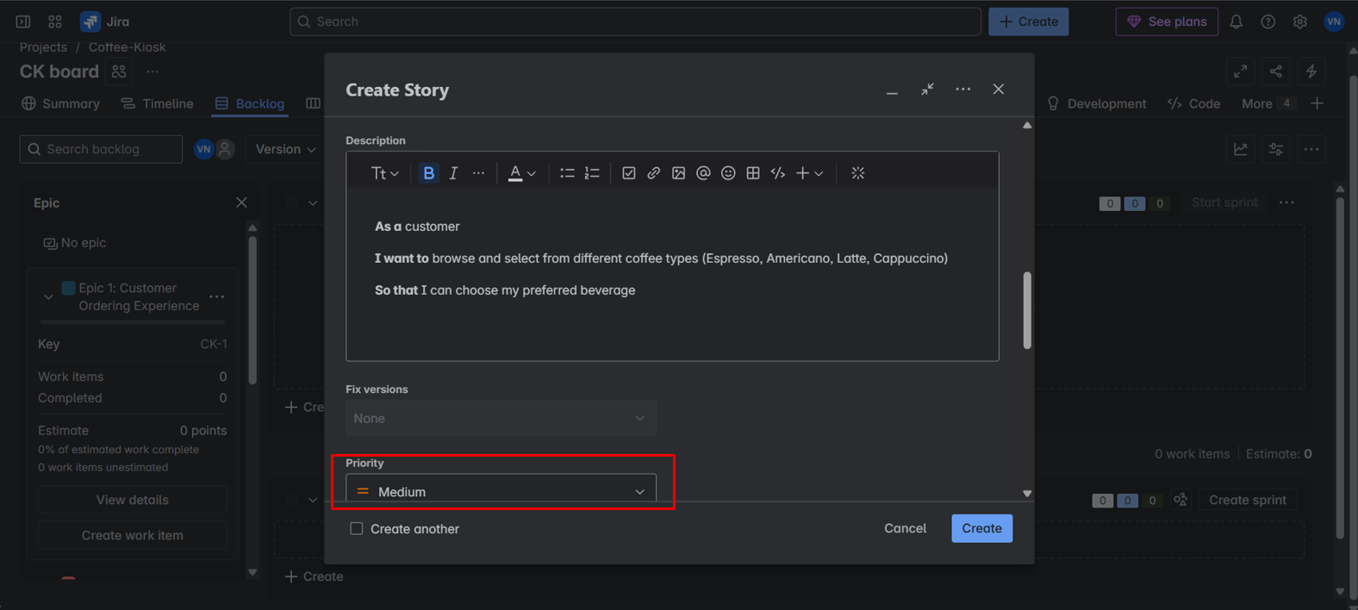

1. **Assign Story Points**

* Use the Fibonacci scale to estimate the relative effort of each story.
* Assign story points based on complexity, time, and uncertainty.

It is common practice to set priorities and assign story points for task during a discussion with the team to rank them from highest priority to the lowest.

Teams starting out with story points use an exercise called [**planning poker**](https://www.atlassian.com/blog/platform/a-brief-overview-of-planning-poker).

Planning poker is a common practice across the company. The team will take an item from the backlog, discuss it briefly, and each member will mentally formulate an estimate. Then everyone holds up a card with the number that reflects their estimate.

If everyone is in agreement, great! If not, take some time (but not too much time–just couple minutes) to understand the rationale behind different estimates. Remember though, estimation should be a high-level activity. If the team is too far into the weeds, take a breath, and up-level the discussion.

***Story Points*:**

**Story points are units of measure for expressing an estimate of the overall effort required to fully implement a product backlog item or any other piece of work. Teams assign story points relative to work complexity, the amount of work, and risk or uncertainty. Values are assigned to more effectively break down work into smaller pieces, so they can address uncertainty.**

**Over time, this helps teams understand how much they can achieve in a period of time and builds consensus and commitment to the solution.  It may sound counter-intuitive, but this abstraction is actually helpful because it pushes the team to make tougher decisions around the difficulty of work.**

An interesting fact, the story points assigned are given from the Fibonacci Series (0, 1, 2, 3, 5, 8, 13, 20, 40, 100…), why is this used?

The Fibonacci sequence is used in Planning Poker because it helps teams estimate story points more effectively, particularly for larger and more complex tasks. The sequence's inherent non-linearity reflects the increasing uncertainty associated with larger tasks, making it a useful tool for agile estimation. E.g.: -

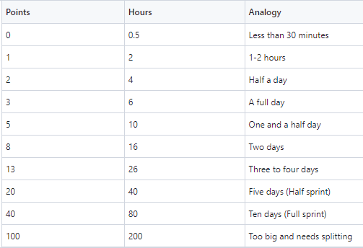

1. **Now assigning story points, find the More field in that you’ll find story points, based on priority. Click on the arrow next to the Epic and you’ll see the story points assigned in total for the Epic and User Stories.** 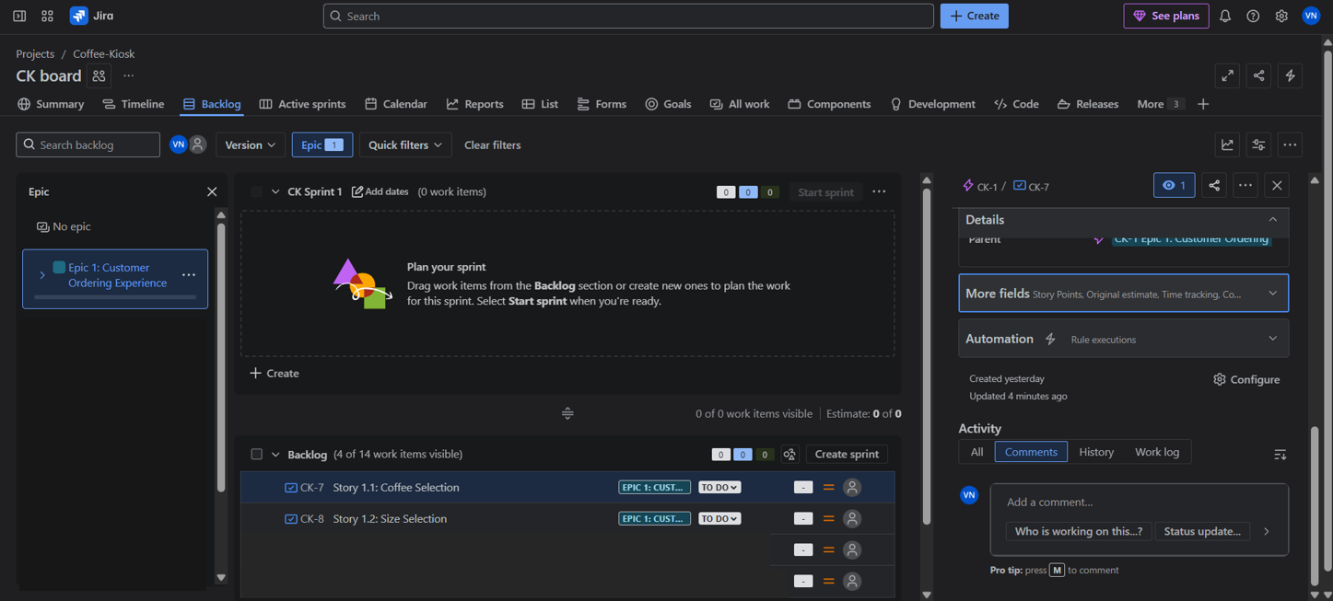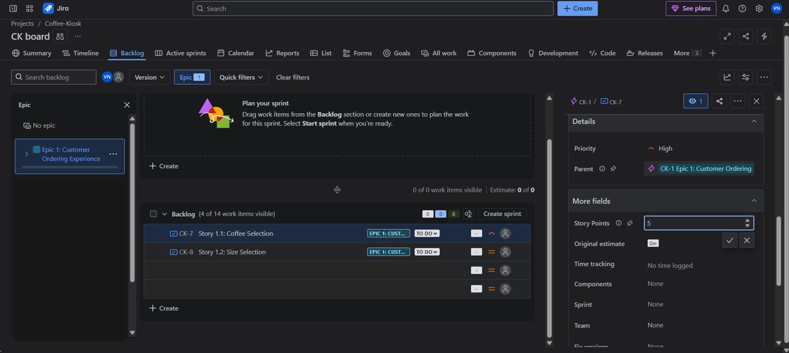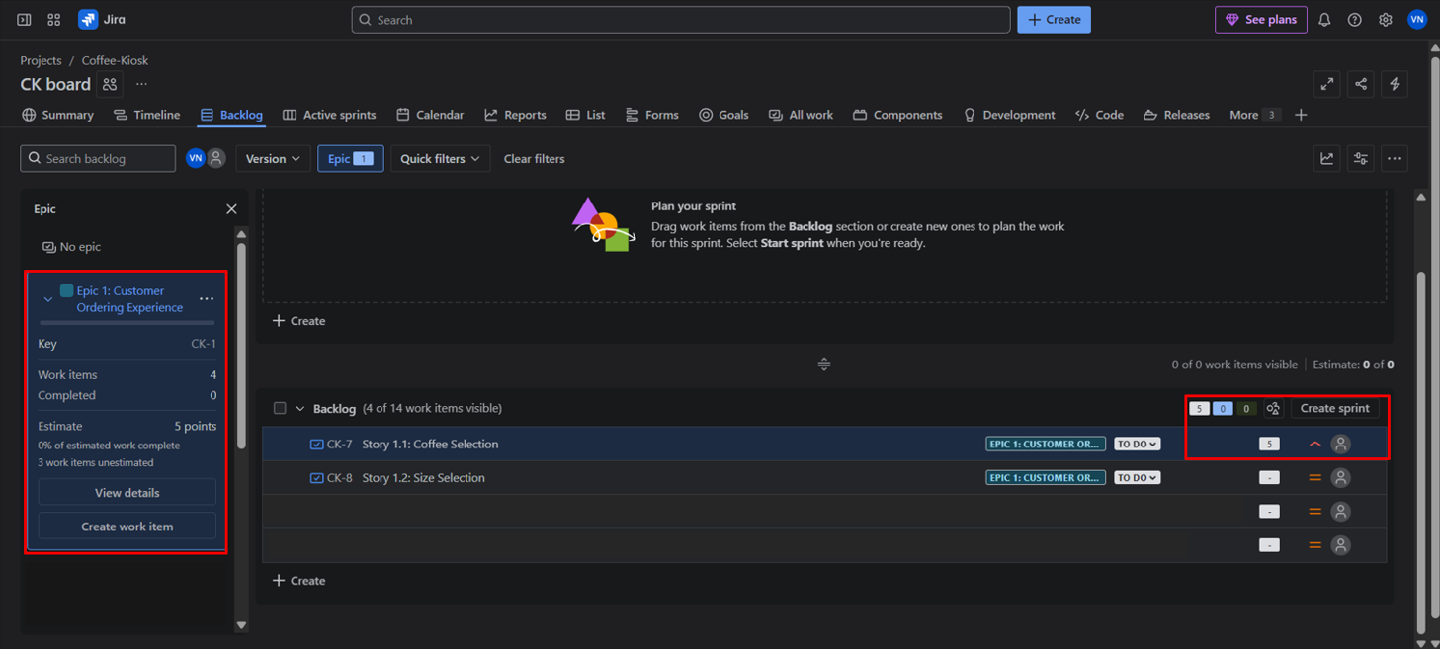
2. **Run Your Sprint**

Once we have defined Epics, User Stories, prioritized them and assigned story points for all Epics and User Stories we move on to create our First Sprint.

***Sprint*:**

**A sprint is a short, time-boxed period when a scrum team works to complete a set amount of work. Sprints are at the very heart of scrum and agile methodologies, and getting sprints right will help your agile team ship better software with fewer headaches.**

**Sprint planning is a timeboxed event within the scrum framework that kicks off the upcoming sprint for agile teams. Sprint planning identifies what tasks will be completed in the sprint and how that work will be achieved.**

**In scrum , the sprint is a set period of time where all the work is done. However, before you can leap into action you have to set up the sprint. You need to decide on how long the time box is going to be, the sprint goal, and where you're going to start. The sprint planning meeting kicks off the sprint by setting the agenda and focus. If done correctly, it also creates an environment where the team is motivated, challenged, and can be successful. Bad sprint plans can derail the team by setting unrealistic expectations.**

* Create **Sprint 1** (1-week duration).
* Drag and drop selected stories into the sprint.
* Start the sprint and simulate task progress:
  + Move tasks from **To Do → In Progress → Done** to reflect their completion.
    1. **Click the check boxes for Epic or User Stories you want to do for the Sprint. Drag and Drop them to the top where it says Sprint 1.** 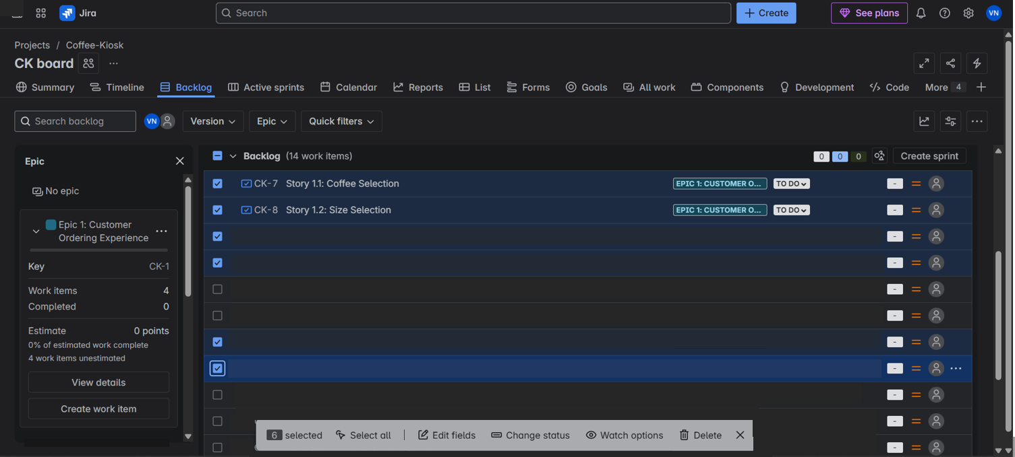

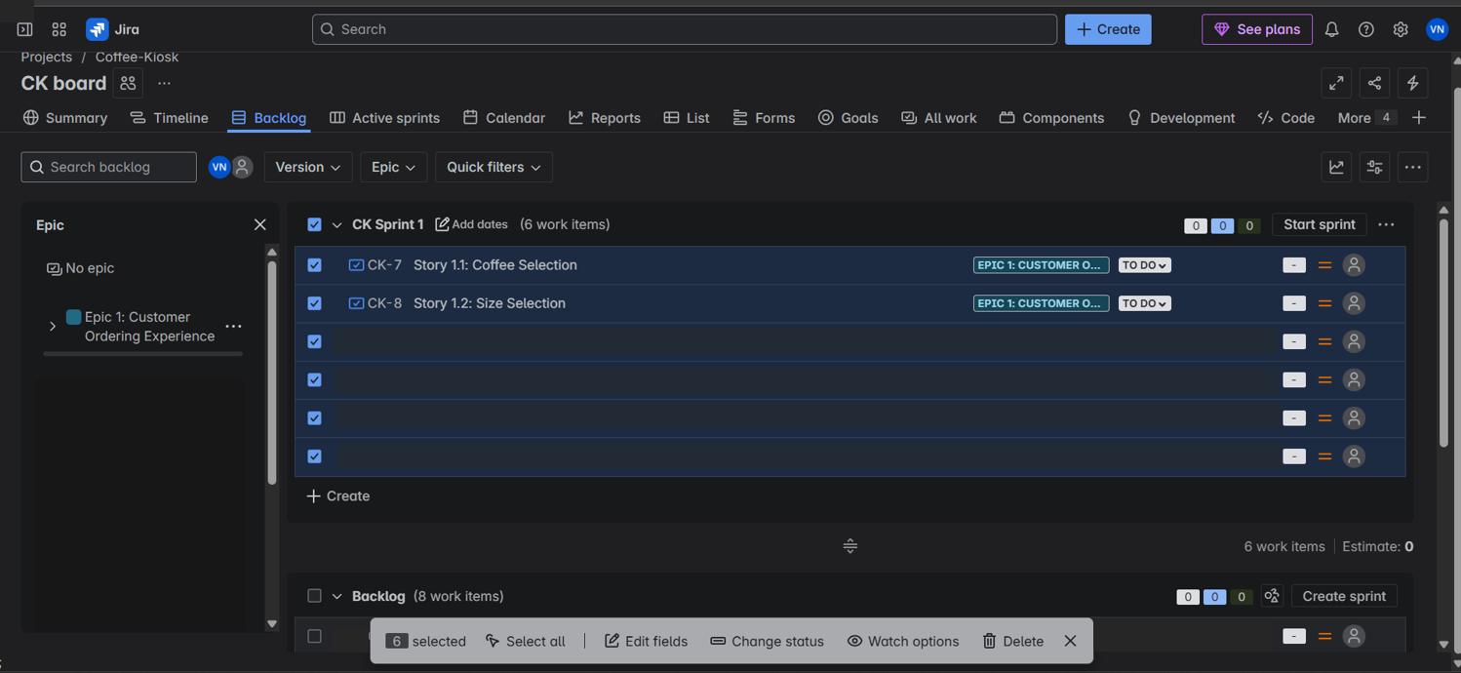

* + 1. **As seen above you have now chosen or populate the tasks, user stories that need to be completed for the Sprint. Click on Start sprint. Choose the start and end date for the sprint and click on start. For this lab set 1 week as the sprint duration.** 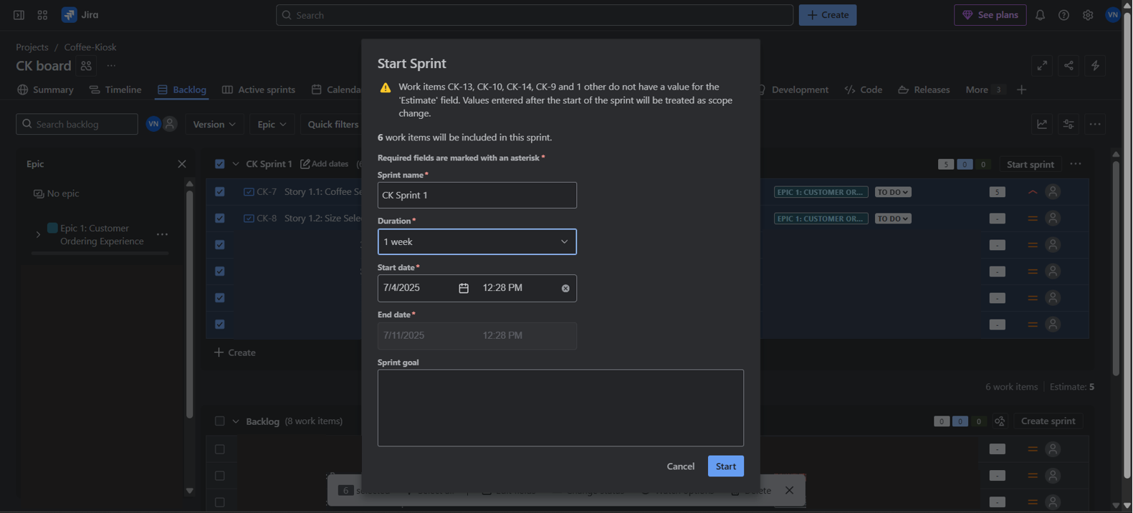
    2. **On clicking Start, it takes you to the Active sprints panel where you’ll see all the User Stories populated in the To Do column.**

**Congratulations!!!!**

**You have now setup your First Sprint for this Project, learned how SCRUM boards are set for projects and how AGILE-SCRUM methodology works.**

**You can move the User Stories from To Do to In Progress to Done, as and when the User Stories are being completed.**

**For this lab, since you are simulating a “Sprint” you can go ahead and move the tasks from To Do to In Progress, wait a few minutes and then move them to Done. The SCRUM Board works like a KANBAN board as well, which means you move the task in order of priority and ranking.**

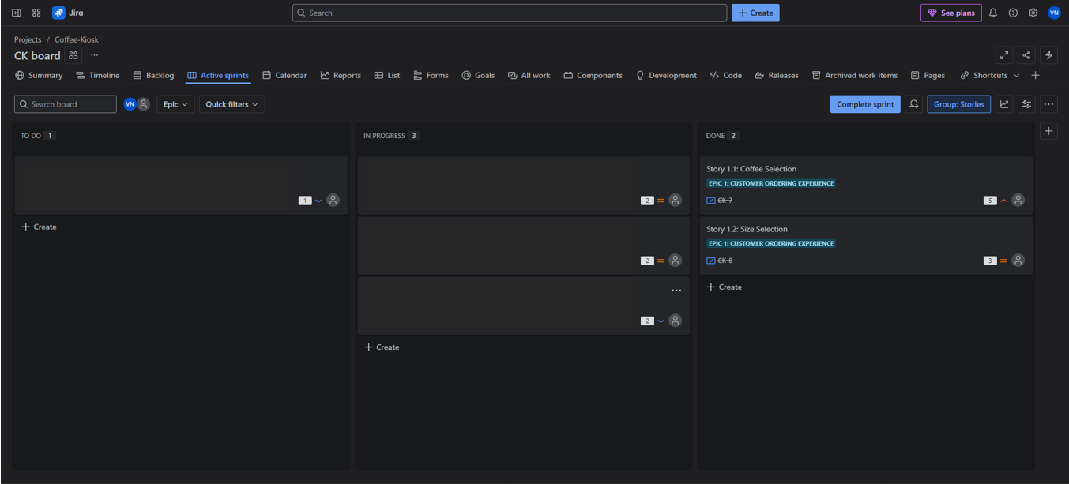

* + 1. **After you complete moving the User Stories from one column to the next in order of progress, click on complete sprint to end your First Sprint.** 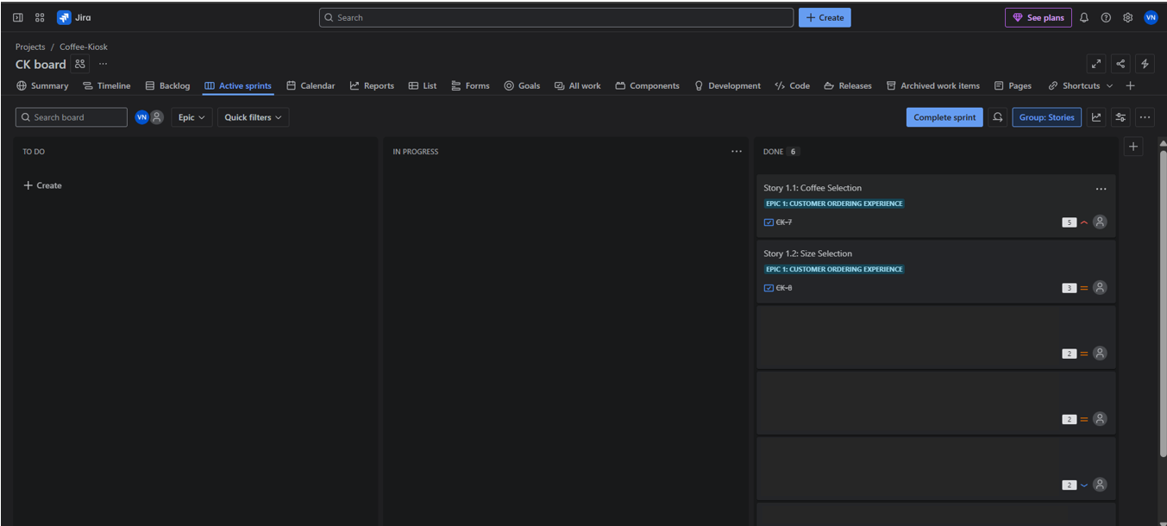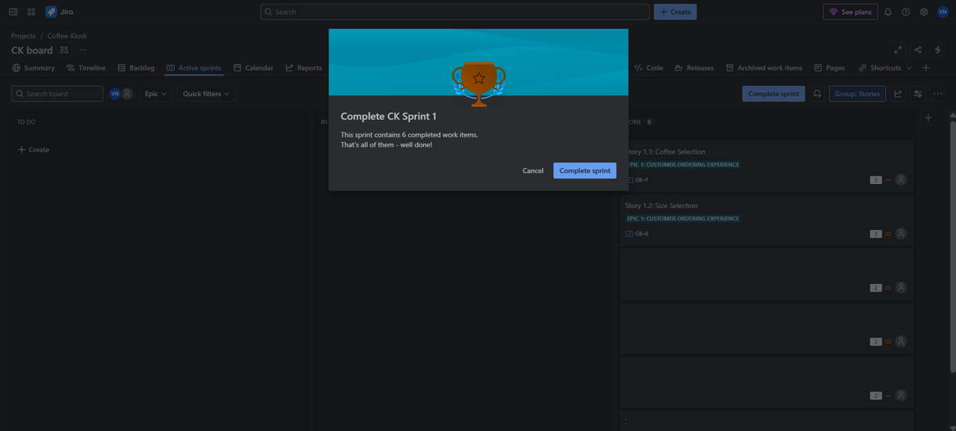
    2. **You’ll be taken back to the Backlog panel where you can go ahead and create your next Sprints as per AGILE-SCRUM methodology.** 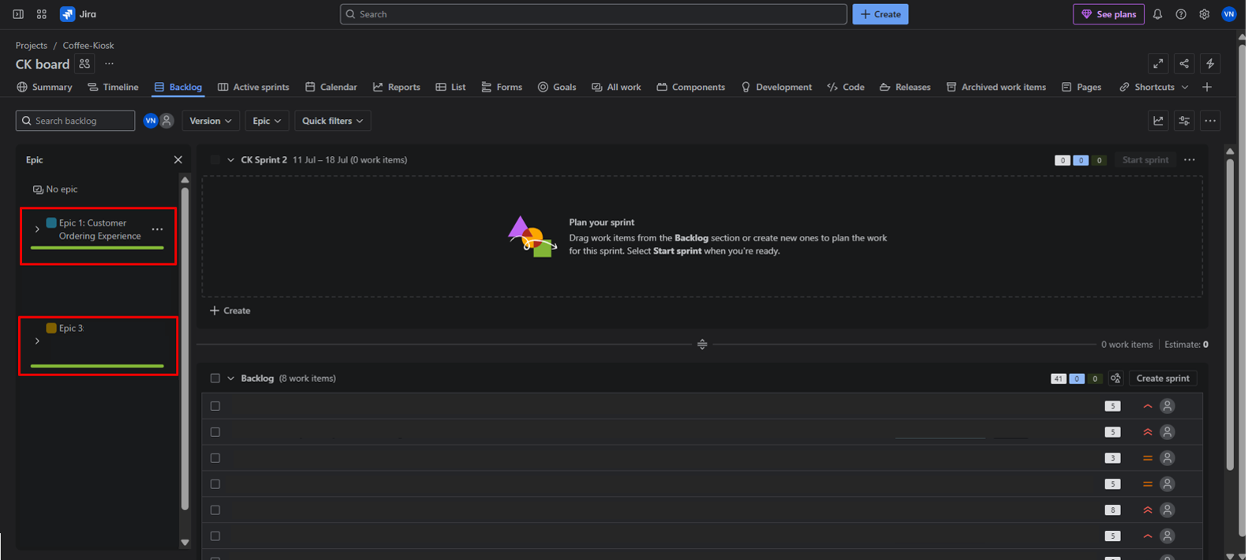
    3. **You can see the progress bars on the Epics that have been completed, if you open them and see the details, it shows the completion and total points.** 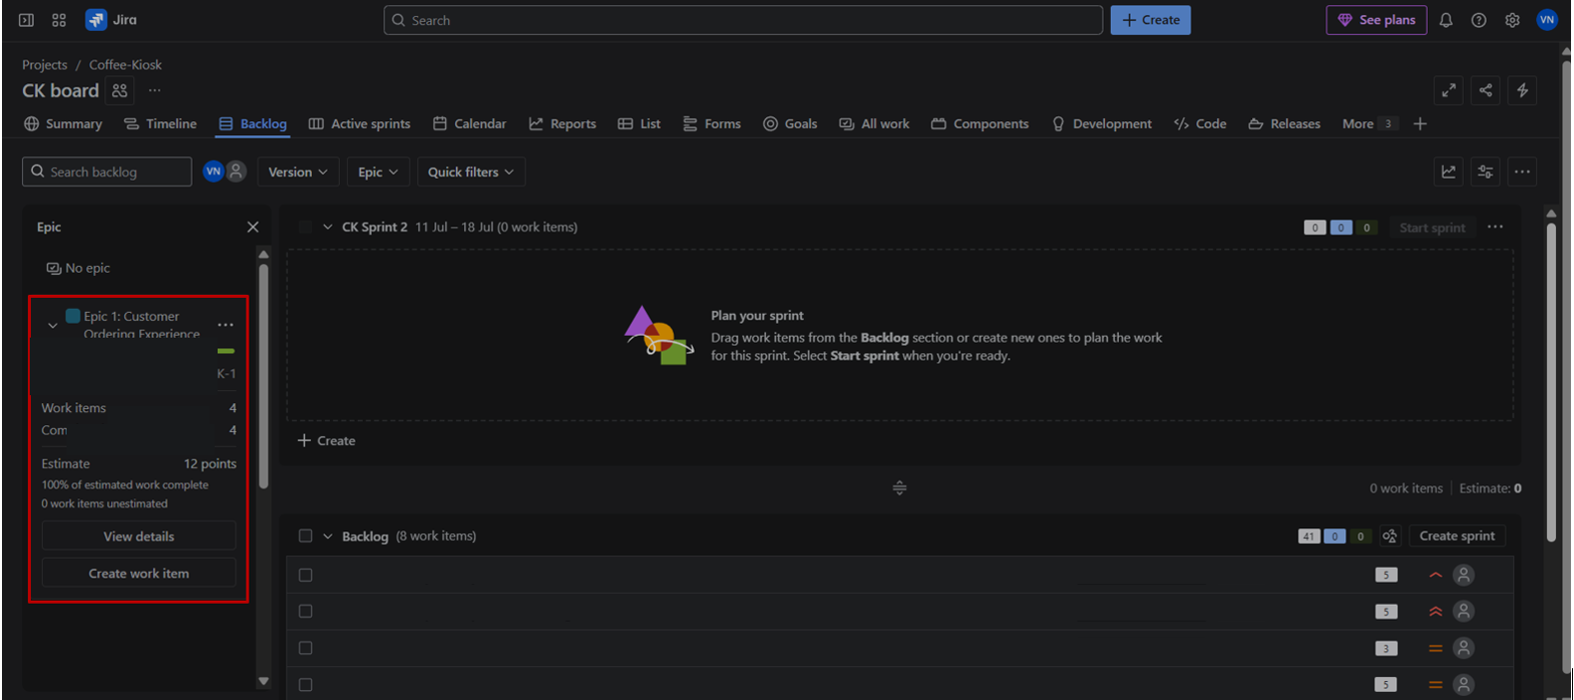

**Finish 2 sprints.**

1. **Generate a Burndown Chart**

* Go to **Reports > Burndown Chart**.
* Observe how story points are completed across the sprint.
* Reflect on any delays, early completions, or inconsistencies.

**A burndown chart shows the amount of work that has been completed in an epic or sprint, and the total work remaining. Burndown charts are used to predict your team's likelihood of completing their work in the time available. They're also great for keeping the team aware of any scope creep that occurs.**

**Burndown charts are useful because they provide insight into how the team works. For example:**

* **If you notice that the team consistently finishes work early, this might be a sign that they aren't committing to enough work during sprint planning.**
* **If they consistently miss their forecast, this might be a sign that they've committed to too much work.**
* **If the burndown chart shows a sharp drop during the sprint, this might be a sign that work has not been estimated accurately, or broken down properly.**

How to read this chart??

* Understanding the sprint burndown chart

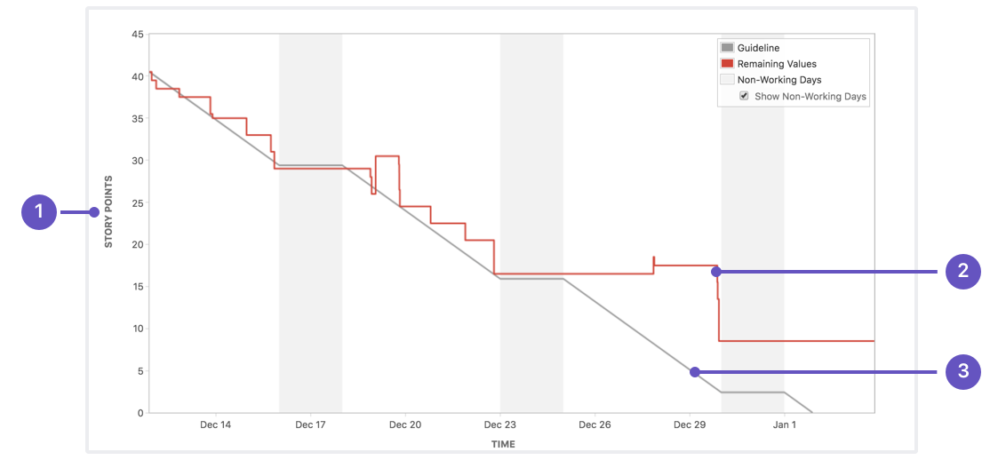

* **Estimation statistic**: The vertical axis represents the estimation statistic that you've selected.
* **Remaining values**: The red line represents the total amount of work left in the sprint, according to your team's estimates.
* **Guideline**: The grey line shows an approximation of where your team should be, assuming linear progress. If the red line is below this line, congratulations - your teams on track to completing all their work by the end of the sprint. This isn't foolproof though; it's just another piece of information to use while monitoring team progress.
  1. **Click on the Reports panel, next to Calendar which is next to Active Sprints.** 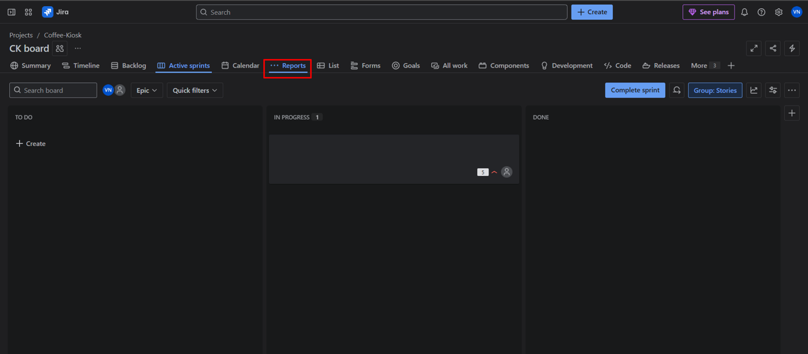
  2. **And choose the Burndown Chart.** 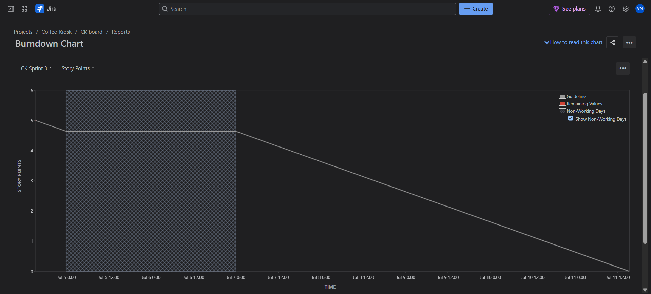

## Reflection Questions:

1. Did your estimations reflect the actual effort?
2. Was your backlog well-prioritized?
3. How did your simulated sprint align with your plan?
4. What insights did the burndown chart give about your team’s capacity?